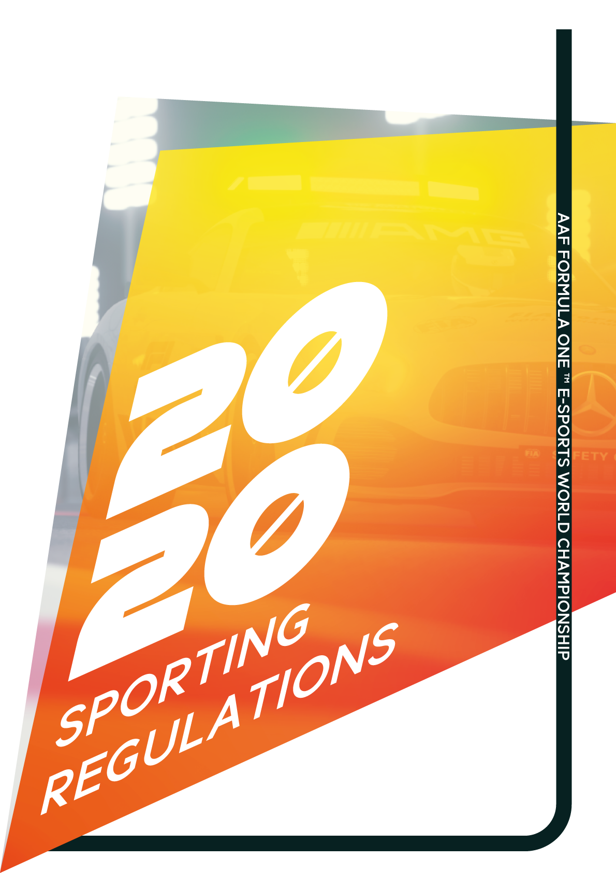

2020 AAF Formula One™ Esports World Championship Sporting Regulations

# Index 1 – The Championship

|  |  |  |
| --- | --- | --- |
| **Article** | **Content** | **Page** |
|  |  |  |
| 1.0 | The Regulations |  |
| 2.0 | Conditions of the Championship |  |
| 3.0 | Driver Prerequisites |  |
| 4.0 | The Championship |  |
| 5.0 | Organization of Events |  |
| 6.0 | Protests and Appeals |  |
| 7.0 | Sanctions |  |
| 8.0 | Meetings |  |
| 9.0 | Car and Personnel Requirements |  |
| 10.0 | General Safety |  |
|  |  |  |

# Index 2 – Racing Parameters

|  |  |  |
| --- | --- | --- |
| **Article** | **Content** | **Page** |
|  |  |  |
| A | Scrutineering |  |
| B | Driving |  |
| C | Definitions of Track Elements (Pits, Tracks, Run-off etc.) |  |
| D | Starting Parameters |  |
| E | Refueling |  |
| F | Free Practice Events |  |
| G | Qualification Events |  |
| H | The Grid |  |
| I | Starting Procedure |  |
| J | The Race |  |
| K | Incidents During the Race |  |
| L | Safety Car |  |
| M | Virtual Safety Car |  |
| N | Suspension of Race |  |
| O | Resuming a Race |  |
| P | Finishing a Race |  |
| Q | Classification |  |

1.0 The Regulations

The AAF will organize the AAF Formula One™ Esports World Championship also referred as (the Championship) which is the property of the AAF & McLaren and comprises one title of World Champion. It consists of the Formula One Grand Prix races which are included in the Formula One calendar and in respect of which if required any external organizers have agreements with the AAF. **All the participating parties undertake to apply as well as observe the rules governing the Championship and must hold AAF Super Licenses which are issued to drivers, competitors, officials, organizers and circuits.**

1. **Interpretation**

The text of these Sporting Regulations shall be interpreted and referenced in English which will be used should any dispute arise as to their interpretation. Headings of this document are for ease of reference and do not form part of these regulations.

1. **Duration**

These Regulations apply to the Championship and may not be changed after the 20th of April for the preceding year with the unanimous agreement of all competitors, save as provided in Article 1.3.

1. **Exceptions to 1.2**

Notwithstanding the provisions of **Article 1.2**, specific articles stated in **1.3a** may be changed after the 20th of April following proposal from the AAF with the agreement of at least 60% of competitors involved. Else 1.3b applies.

* 1. Articles 19,20
  2. Any amendments to any other articles will require unanimous agreement of all competitors.
  3. Changes to the non-alphabetical section of the regulation deemed fundamental, can be made by the AAF overriding with prior discretion.

2.0 Conditions of the Championship

1. All drivers, competitors and officials participating in the Championship undertake, on behalf of themselves, their sponsors, agents and suppliers, to observe all the provisions of the AAF Formula One Technical Regulations and AAF Sporting Regulations together referred to as “the Regulations”.
2. The Championship and each of its Events is governed by the AAF in accordance to the regulations.
3. It is the driver’s responsibility to ensure that themselves and persons concerned observe all the requirements of the Regulations.
4. Competitors must ensure that their car comply with the conditions of eligibility throughout the practice and race.
5. The presentation of a car for scrutineering (**Art. 25.1**) will be deemed as a statement of conformity.
6. All persons involved in any capacity must always be made visually distinguishable through a pass or virtual role-set.
7. All drivers and members involved participating in the Championship must hold an AAF Super License graded Type A to Type D.
8. With the exception of a reprimand, when a penalty is applied under the Sporting Regulations, the AAF stewards may impose penalty points on a driver’s Super License.  
     
   Accumulation of 15 penalty points will suspend the driver from racing further in the championship for that annum.  
     
   Penalty points will remain on a driver’s Super License for that respective year and removed per 12 month Anniversary of the Sporting regulations.

3.0 Driver Prerequisites

1. All drivers, competitors and officials participating in the Championship must use computational hardware that provide sufficient processing power and visual elements to be able to identify and react to events in a safely manner without interruption.
2. Drivers must not have any medical conditions that may impede the ability of themselves to identify and respond visually and audibly.
3. Drivers must be able to communicate with adequate fluency (as determined by the AAF when a super license is presented) for the English Language.
4. Drivers have suitable input hardware that hold an element of response when driving, such as a steering wheel.  
     
   A computer mouse is not considered an acceptable racing apparatus.
5. Drivers must be aged 16 or over when competing in the Championship
6. Drivers who hold a super license consent to broadcasting should any event be broadcasted.   
   1. As well as providing consent, drivers agree to the Terms of Service and guidelines for these following media platforms:  
      1. Twitch
      2. YouTube
      3. Instagram.
   2. Within this consent process. In efforts to streamline the enforcement of the ToS per platform a member may be sanctioned exclusively from their license for inappropriate behavior.
7. Drivers must immediately report changes that may affect any section in Article 3.

4.0 The Championship

1. The AAF Formula One™ Esports World Championship Driver’s title will be awarded to the driver who has the highest number of points taking into consideration all the valid results obtained during the events which have taken place.
2. Points for the title will be awarded at each event according to the following scale:

1st : 25 pts

2nd : 18 pts

3rd : 15 pts

4th : 12 pts

5th : 10 pts

6th : 8 pts

7th : 6 pts

8th : 4 pts

9th : 2 pts

10th : 1 pt.

In addition to the above, one point will be awarded to the driver who achieved the fastest valid lap time of the race. No point will be awarded if the fastest valid lap time is achieved by a driver who was classified outside the top ten positions.

1. If the race is suspended and cannot be resumed, no points will be awarded if the leader has completed less than two laps.
2. If two or more drivers finish the season with the same number of points, the higher place in the championship shall be awarded to:  
   1. The holder of greater number of first places.
   2. If not, then the greatest number of second places,
   3. If not, then the greatest number of third places and so on until a winner emerges.
   4. If such criteria fail, a nomination shall be made.
3. Events are reserved for Formula Hybrid cars as defined in the Technical Regulations.
4. The distance of all races, from the start signal to the end-of-race signal shall be equal to the least number of laps that exceed a distance of 150km.  
     
   However should two hours’ elapse before the race distance is completed, the leader will be shown an end-of-race signal as he crosses the control line.  
     
   Only under the circumstances below should any exception be made to above:  
   1. The distance of the race in Monaco shall be equal to the least number of laps which exceed 130km.
   2. Should the race be suspended, the length of the suspension will be added to this period up to a maximum total race time of three hours.
   3. If the formation lap is started behind the safety car the number of race laps will be reduced by the number of laps carried out by the safety car minus one.
5. The maximum number of Events in the Championship is 22, the minimum is 8.
6. An Event which is cancelled with less than one months’ written notice to the AAF will not be considered for inclusion in the following year's Championship unless the FIA judges the cancellation to have been due to force majeure.
7. An Event may be cancelled if fewer than 4 Drivers are available for it upon request.

5.0 Organization of Events

1. The organization of participants will be made of members eligible defined in the Articles: 2.0 and 3.0.
2. The event must be organized to an appropriate standard such that participants and spectators exclusively do not interfere with the functions of the driver, so be it communication or any other means of interference.
3. The AAF Formula One™ Esports World Championship Events will be dated in parallel with the real-life Formula One applicable events.  
   1. In such circumstance that the events are no longer in sync with the Formula One race calendar; changes to the timetable can be made to accelerate or delay the frequency of events on a weekly basis with an 80% majority agreement.
   2. Provided that no two events can be held within the same week.
4. Should an event be broadcasted, the following information must be included in any format accompanying the broadcast:  
   1. The name of the team and driver.
   2. The make of the competing car.
   3. The driver’s number.
5. Broadcasts must display the Asfalto Ascari brand and its respective title sponsors.

6.0 Protests & Appeals

1. Protests shall be made in accordance with the Code.
2. Appeals may not be made against the decision concerning the following:  
   1. Penalties imposed under Articles XX.X
   2. Any drop of grid positions imposed.
   3. Any decision taken by the stewards in relation to Article 1, 2, 3, 4, or 5.

7.0 Sanctions

1. The stewards may inflict the penalties specifically set out in these Sporting Regulations in addition to or instead of any other penalties available to them under the Code.
2. Any driver who receives three reprimands in the same Championship season will, upon the imposition of the third, be given a ten-grid place penalty at that Event. If the third reprimand is imposed following an Incident during a race the ten-grid place penalty will be applied at the driver’s next Event. The ten-grid place penalty will only be imposed if at least two of the reprimands were imposed for a driving infringement.

8.0 Meetings

1. Meetings, chaired by the race director, may take place at least 1 hour before the start of P1 and 30 minutes after the end of P3. The first must be attended by drivers if not then the second. Should the race director consider another meeting necessary it will take place a day before the start of the of any race.

9.0 Car and Personnel Requirements.

TBC as Technical regulations are to be released.

10.0 General Safety

1. Drivers who experience or may be prone to the following conditions must immediately report to the race director of the event:  
   1. Anxiety, Asthma, Diabetes, Dizziness, Epilepsy, Fatigue, High Blood Pressure, Headaches or Migraines.
   2. Arm, Back, Neck, Leg or Foot pain.
2. Should a driver experience any symptoms as defined in 10.1a, he would be required to follow the advice of the race director accordingly.
3. The racing apparatus should be set up with an appropriate level of feedback to prevent injury to the driver.   
     
   The racing apparatus must be untampered, absent of objects that may cause injury such as sharp or hazardous protrusions, flanges and materials.  
     
   All Direct drive systems must be accompanied by a physical kill-switch.
4. The driver must set an appropriate volume for his racing environment and communications relays, such that it would not induce the chance of long-term hearing damage.
5. The driver must be racing in a safe and clear environment, free of objects that may impose an electrical or fire hazard.